HACKATHON

CS310 DBMS

Name :- sunil kumar patidar

Roll no:- 20BCS131

Date:- 4

th Feb,2022

Q1)

Schema:-

20BCS131Classes {

Lessonindex : INT ,

Level : INT,

Pool : INT,

Instructor : INT ,

SectionID : INT ,

Semester : INT,

Days : TEXT(20) ,

Time : DATETIME ,

Limit : INT ,

Enrolled : INT ,

Price : INT ,

}

20BCS131Enrollment {

LessonIndex : INT ,

SID : INT ,

Status : TEXT(30) ,

Charged : BIT ,

AmountPaid : INT ,

DateEnrolled : DATETIME,

}

20BCS131Students {

SID : INT ,

FirstName : TEXT(20) ,

MiddleInitial : TEXT(3) ,

LastName : TEXT(30) ,

Suffix : TEXT (3) ,

Birthday : DATETIME ,

LocalStreet : TEXT(30) ,

LocalCity : TEXT(20) ,

LocalPostalCode : TEXT(6) ,

LocalPhone : INT ,

}

20BCS131Staff {

StaffID : INT ,

FirstName : TEXT(20) ,

MiddleInitial : TEXT(3) ,

LastName : TEXT(20) ,

Suffix : TEXT(3) ,

Salaried : BIT ,

PayAmount : INT ,

}

20BCS131Pool {

Pool : INT ,

PoolName : TEXT(25) ,

Location : TEXT (20) ,

}

20BCS131Levels {

Level : INT ,

ClassName : TEXT(25) ,

}

**Conceptual Diagram**:

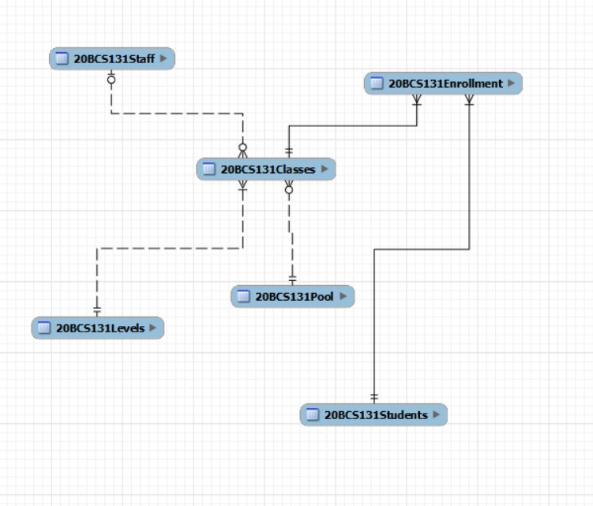

**Q.2Cardinality**

|  |  |  |
| --- | --- | --- |
| 20BCS131Classes | Mandatory 1 –  Mandatory Many | 20BCS131Enrollment |
| 20BCS131Enrollment | Mandatory 1 –  Mandatory Many | 20BCS131Students |
| 20BCS131Staff | Optional 1 – Optional  Many | 20BCS131Classes |
| 20BCS131Pool | Mandatory 1 – Optional  Many | 20BCS131Classes |
| 20BCS131Levels | Mandatory 1 –  Mandatory Many | 20BCS131Classes |

**Degree:**

|  |  |
| --- | --- |
| **Relation** | **Degree** |
| **Classes** | **11** |
| **Enrollment** | **6** |
| **Staff** | **7** |
| **Pool** | **3** |
| **Levels** | **2** |
| **Students** | **10** |

**Q3 Physical Data Model:**

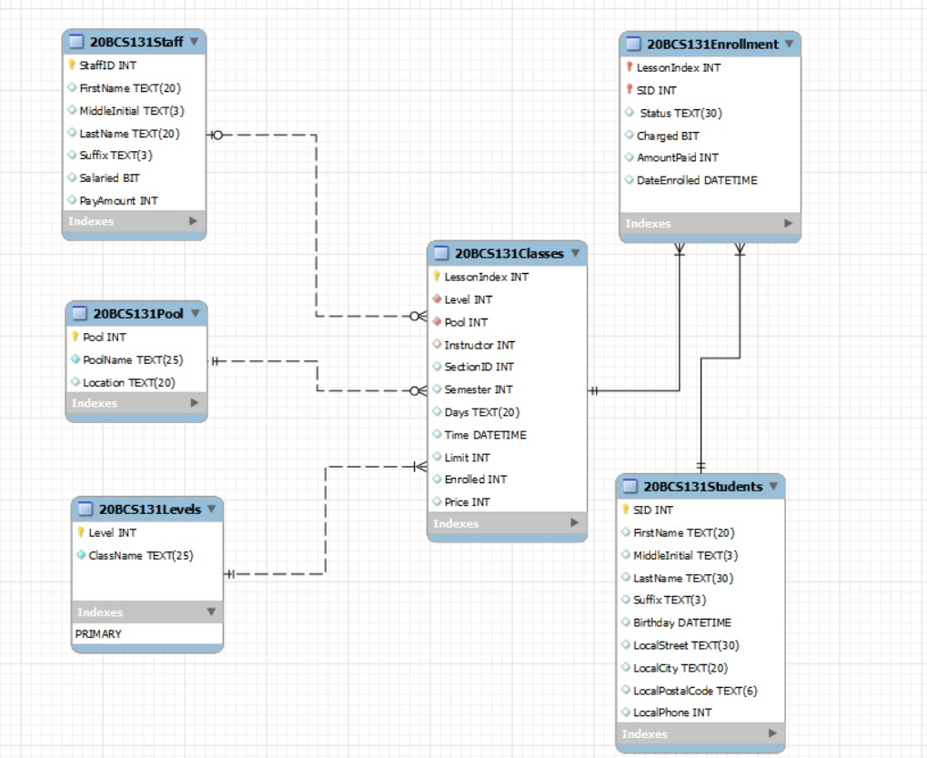

**Q4 Weak Entities**

20BCS131Enrollment is a weak entity because it does not have a primary key ,

It forms weak relationships which is denoted by straight lines .

It forms a M:N relation between 20BCS131_Students and 20BCS131_Classes,

This entity cannot be made strong since it is an associative entity and already

has a composite key , there wouldn’t be a need to add a primary key of its

own.

**Q5 Data redundancy**

There is no data redundancy in the Database architecture since no two

different tables have same data attributes